Project Design Phase

Solution Architecture

|  |  |
| --- | --- |
| Date | 28 JUNE 2025 |
| Team ID | LTVIP2025TMID43759 |
| Project Name | HematoVision: Advanced Blood Cell Classification Using Transfer Learning |
| Maximum Marks | 4 Marks |

**Solution Architecture:**

Solution architecture bridges the gap between clinical diagnostic needs and AI technology. Its goals are:

* Identify optimal AI solutions for accurate blood cell classification.
* Describe software structure, processes, and data flow to medical stakeholders.
* Define features, development phases, and technical requirements.
* Provide clear specifications for implementation, testing, and delivery.

**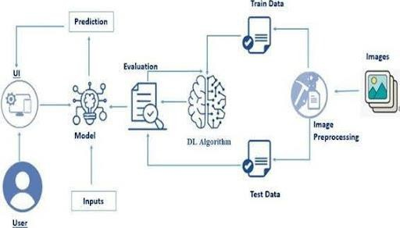****Solution Architecture Diagram:**

**Implementation Phases:**

|  |  |
| --- | --- |
| Phase | Activity |
| 1. | Data Collection: Collect blood cell images dataset (e.g., Kaggle blood cell dataset) |

|  |  |
| --- | --- |
| 2. | Data Pre-processing: Resize, normalize, and clean images. |
| 3. | Data Augmentation: Improve dataset  variability. |
| 4. | Data Splitting: Divide data into training, validation, and testing sets. |
| 5. | Model Building: Import necessary libraries  and define the transfer learning model architecture. |
| 6. | Training & Testing: Train the model and evaluate performance. |
| 7. | Model Saving: Save trained model for future inference. |
| 8. | Application Development: Build web app  with HTML, Python (Flask), integrate model. |
| 9. | User Interaction: Provide UI to upload images and display predictions. |